AZURE VIRTUAL NETWORKS
Azure Virtual Network (VNet) is the fundamental building block for your private network in Azure. VNet enables many types of Azure resources, such as Azure Virtual Machines (VM), to securely communicate with each other, the internet, and on-premises networks. VNet is similar to a traditional network that you'd operate in your own data center, but brings with it additional benefits of Azure's infrastructure such as scale, availability, and isolation.
Azure Virtual Network | Microsoft Docs

SUBNETS:
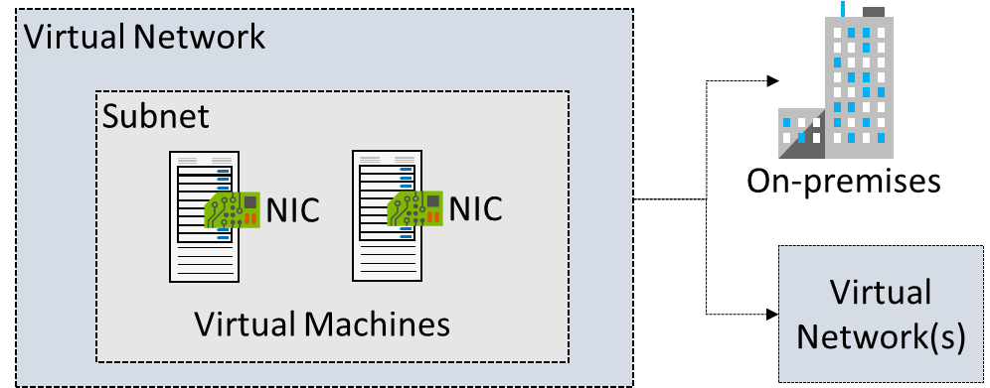

Under the VNet, we must understand what Subnet is and how it works.

Subnetting is the process of dividing a network into small networks,
- We can divide the VNet IP Range into multiple Parts of unique Subnet IP ranges.
- Resources within the subnet will communicate with each other and also communicate across the subnets in the same VNet with the help of Network Security Groups, so communication between the Subnets is up to our choice.
For Example,

There are two classrooms in a school. Consider a classroom as a subnet.

Class A leader wants to get a duster from Class B, but the class was enclosed, he can go by open door.

Here the Door is a Network security group, it will act as a firewall for subnets as well as resources in the subnet.
- Resources in different VNets can’t communicate with each other.
Associate Public IP Address to Azure VM:
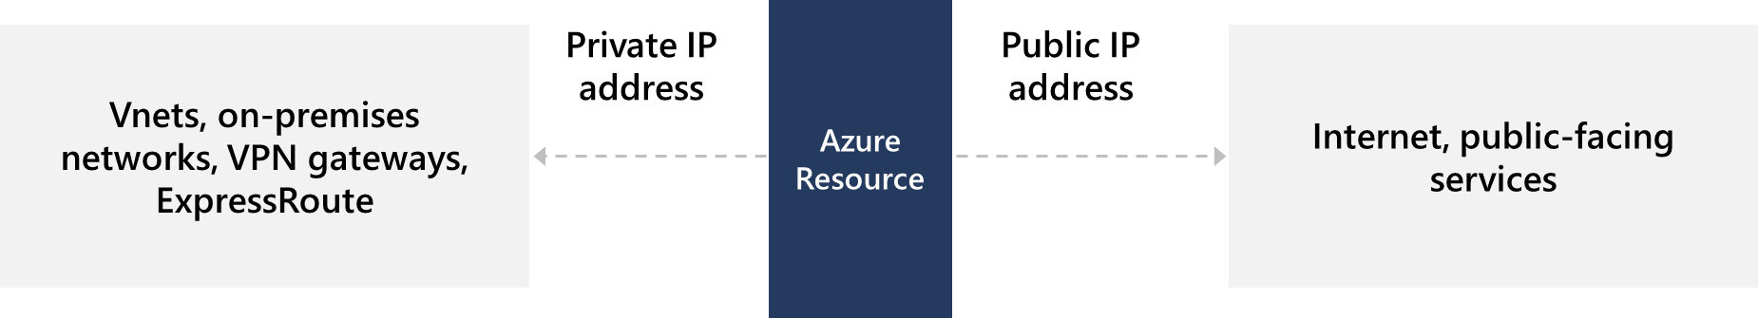
Associate a public IP address to a virtual machine | Microsoft Docs
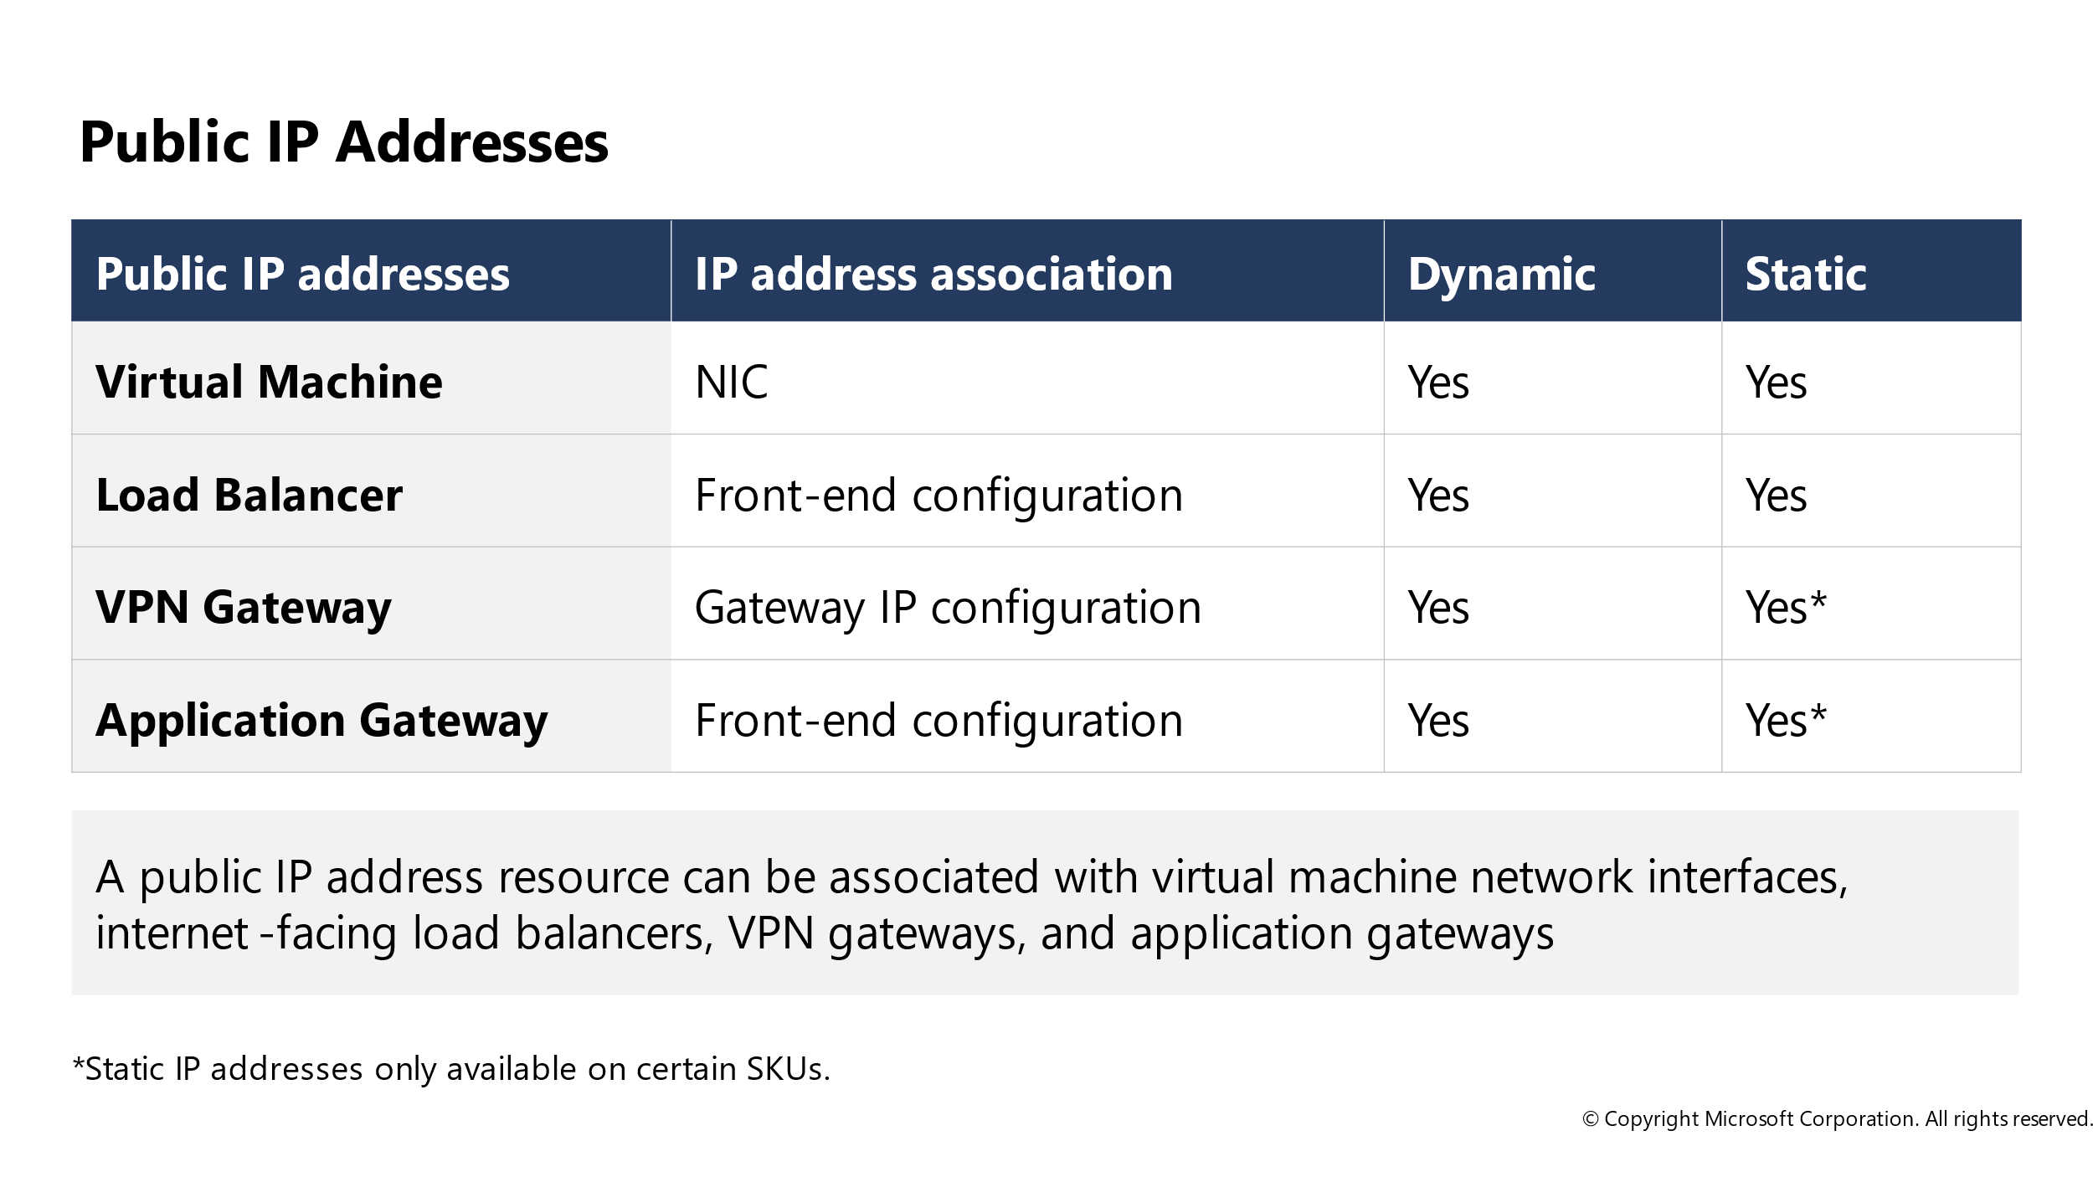
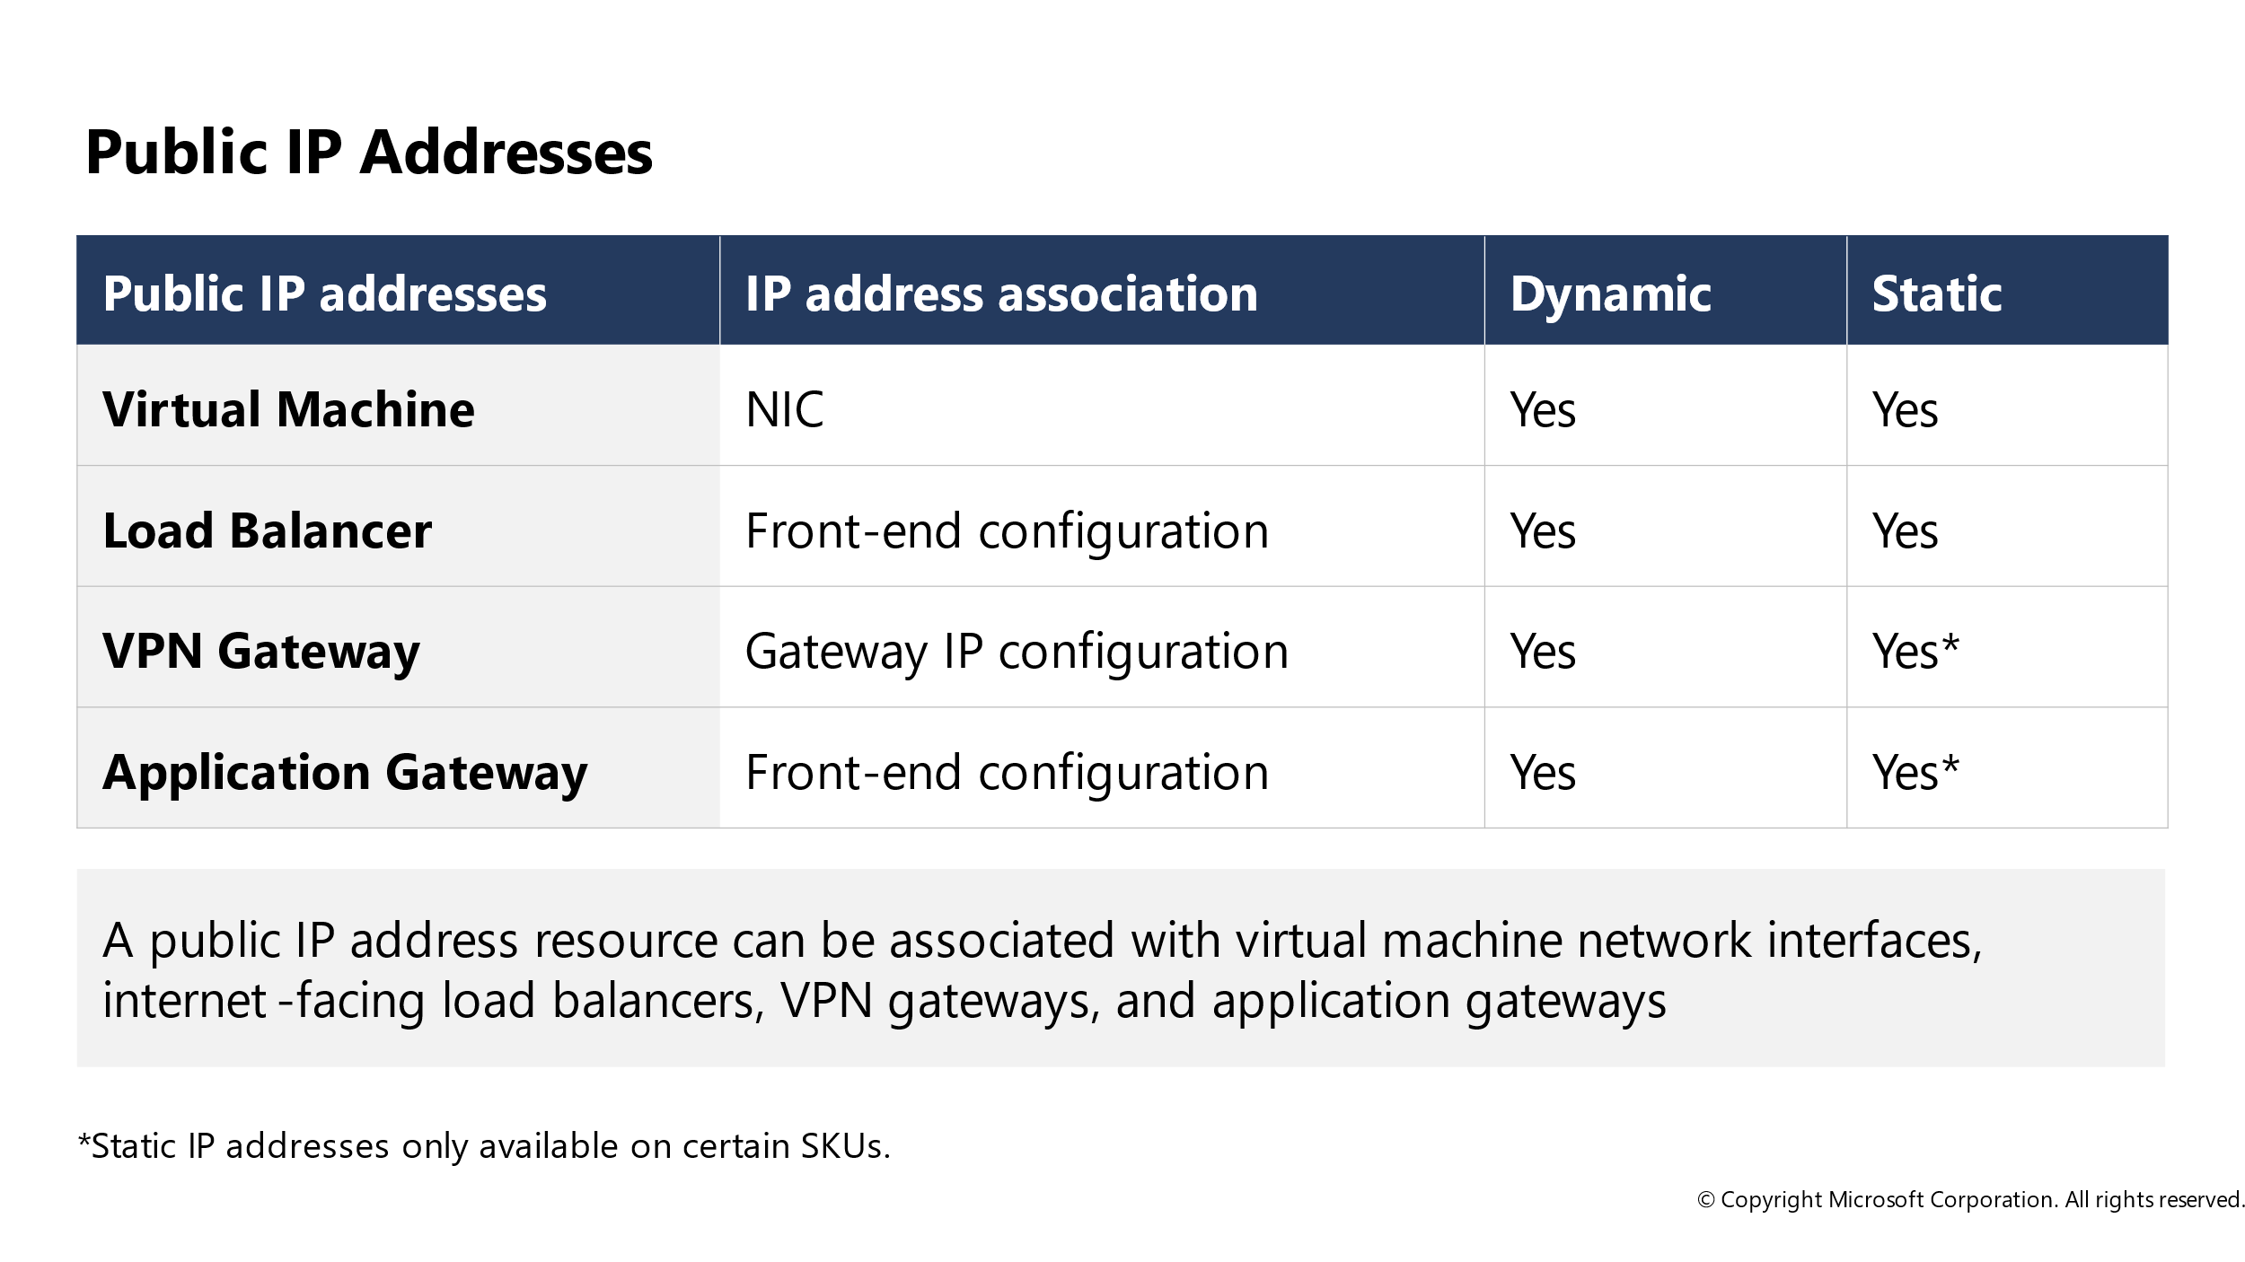

NETWORK SECURITY GROUPS:
Security rules in network security groups enable you to filter the type of network traffic that can flow in and out of virtual network subnets and network interfaces. To learn more about network security groups, see Network security group overview. Next, complete the Filter network traffic tutorial to gain some experience with network security groups.
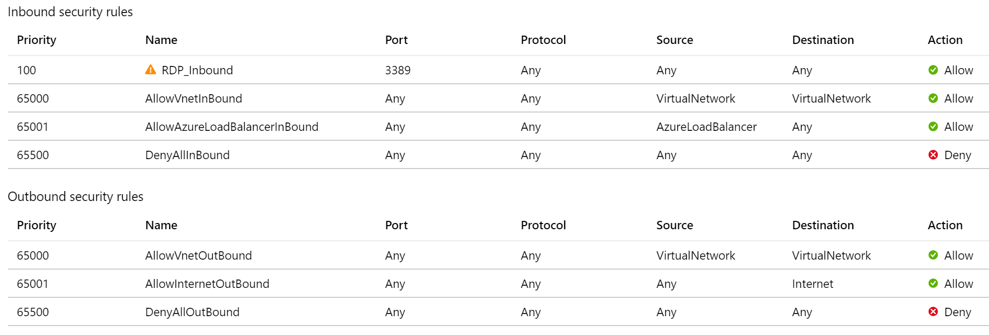

AZURE FIREWALL:
Azure Firewall is a managed, cloud-based network security service that protects your Azure Virtual Network resources.
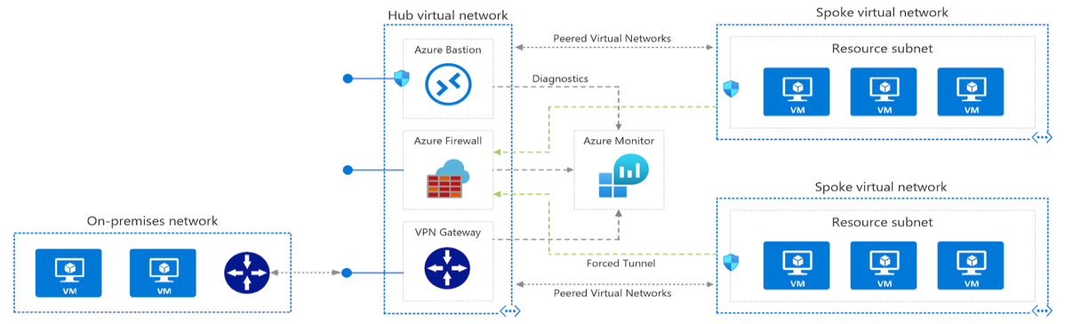

NAT rules. Configure DNAT rules to allow incoming connections
Network rules. Configure rules that contain source addresses, protocols, destination ports, and destination addresses
Application rules. Configure fully qualified domain names (FQDNs) that can be accessed from a subnet

AZURE DNS:
DNS | Microsoft Azure
Azure DNS is a hosting service for DNS domains that provides name resolution by using Microsoft Azure infrastructure. By hosting your domains in Azure, you can manage your DNS records by using the same credentials, APIs, tools, and billing as your other Azure services.
You can't use Azure DNS to buy a domain name. For an annual fee, you can buy a domain name by using App Service domains or a third-party domain name registrar. Your domains then can be hosted in Azure DNS for record management. For more information, see Delegate a domain to Azure DNS.
The following features are included with Azure DNS.

AZURE PRIVATE DNS:
The Domain Name System, or DNS, is responsible for translating (or resolving) a service name to an IP address. Azure DNS is a hosting service for domains and provides naming resolution using the Microsoft Azure infrastructure. Azure DNS not only supports internet-facing DNS domains, but it also supports private DNS zones.
Azure Private DNS provides a reliable and secure DNS service for your virtual network. Azure Private DNS manages and resolves domain names in the virtual network without the need to configure a custom DNS solution. By using private DNS zones, you can use your own custom domain name instead of the Azure-provided names during deployment. Using a custom domain name helps you tailor your virtual network architecture to best suit your organization's needs. It provides a naming resolution for virtual machines (VMs) within a virtual network and connected virtual networks. Additionally, you can configure zones names with a split-horizon view, which allows a private and a public DNS zone to share the name.
To resolve the records of a private DNS zone from your virtual network, you must link the virtual network with the zone. Linked virtual networks have full access and can resolve all DNS records published in the private zone. You can also enable autoregistration on a virtual network link. When you enable autoregistration on a virtual network link, the DNS records for the virtual machines in that virtual network are registered in the private zone. When autoregistration gets enabled, Azure DNS will update the zone record whenever a virtual machine gets created, changes its' IP address, or gets deleted.

